Course Title: Daily Fueling Basics

Grade Level: High School 9-12

Description:
In this course, you will learn the basics of fueling your body for everyday needs and athletic performance and recovery. Your body takes all of the food you consume and turns it into energy. What you put into your body matters. Your body is like an engine, put the wrong fuel in and you have major issues. If you put the correct fuel in, you enhance the performance and longevity of the engine. Creating good, healthy fueling habits now will help you grow and develop appropriately as you transition from your teenage years into adulthood.

Course Image:
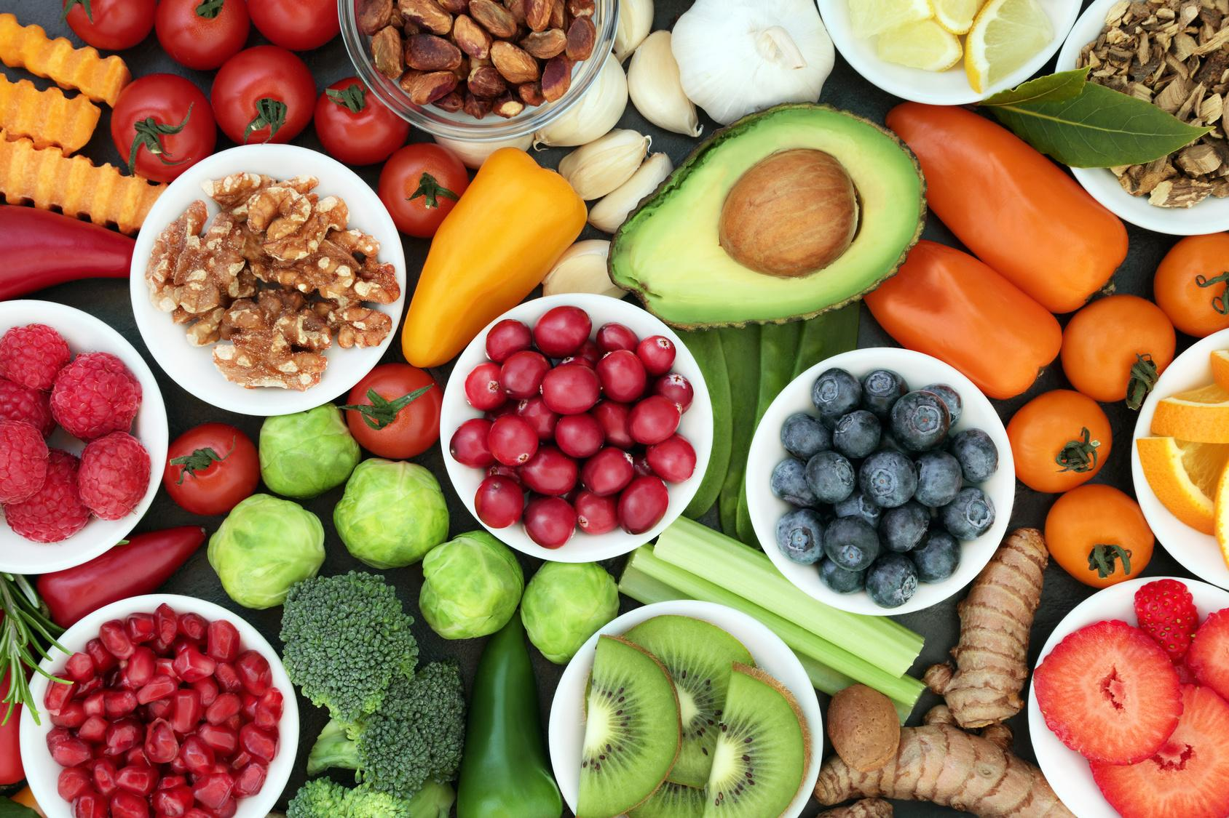
Video URL:
https://www.youtube.com/watch?v=UwQwAYejFOg

